**Dilemma of Health Insurance Companies: Challenge vs. Opportunity**

Undeniably, health insurance companies are facing a very hard time that no one even knows when it will end and whether it can be much harder.

The first challenge comes from unemployment, which leads to the risk of losing members in the future. According to Washington Post, more than 17 million Americans have filed for unemployment benefits in the past four weeks, a rapid and unprecedented deterioration in the U.S. economy that the nation has decided is necessary to combat the deadly coronavirus by keeping as many people as possible at home. Below display two charts that shows the savings rates of the U.S. and China. We see that people have much lower savings in the U.S., which makes U.S. households are much easier to suffer from financial difficulties hence cut down their budget for consumer discretionary. Therefore, it is predictable that insurance many lose their customer if the coronavirus keeps raging around the globe.

Savings Rate in China

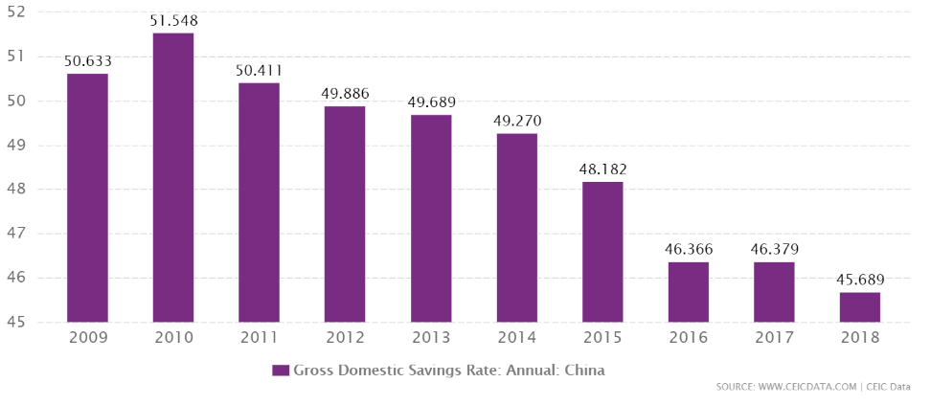

Savings Rate in the U.S.

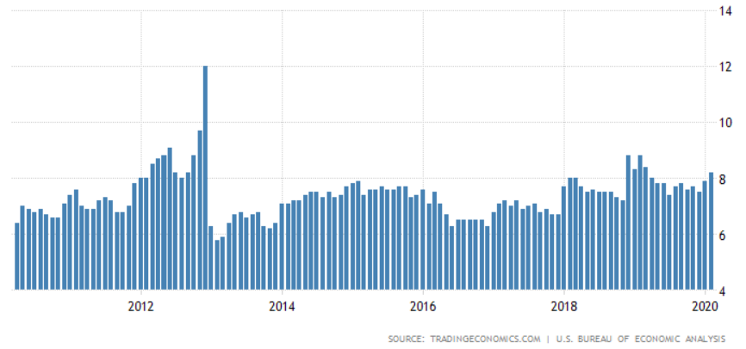

Risks can also be seen in lower wage situation in the future. The United Nations' International Labor Organization (ILO) reported that the coronavirus is expected to decimate global working hours by nearly 7% in the coming months — a dramatic dip equivalent to 195 million full-time jobs worldwide. With roughly half of Americans getting their health insurance from their employer, these layoffs mean not only losing their income but also their medical coverage. During the last big recession, researchers at Cornell University found that 9.3 million Americans lost their health insurance between 2007 and 2009. As people lost work, their employer-provided insurance went away. During this time, roughly six in 10 Americans who lost their jobs became uninsured. Therefore, economy recovery may give hope to industries but households running out of savings, salary reducing and layoffs can still become big problems in maintaining customers.

According to AHIP reporting health insurance providers respond to COVID-19, more and more healthcare insurance company decided to fully cover medically-necessary diagnostic tests for COVID-19 or waive cost-sharing for COVID-19 testing performed at a hospital or approved laboratory. In March, representatives of major health insurance companies met with President Trump, where they voluntarily committed to covering COVID-19 testing without cost sharing such as copays and coinsurance. Although this saves more lives, it becomes a huge burden to healthcare insurance companies. Analysts for California’s insurance marketplace recently projected insurers nationwide could end up spending as much as $251 billion to cover care for coronavirus patients.

While the expenses of infectious diseases may be taken in to consideration by insurance companies, hardly can such great global coronavirus pandemic be predicted. So, the combination of all the above does seem like a “perfect storm” that hurts the industry badly.

**Healthcare Sub-Industries**

The chart below shows the VR distributions of Sector Health Insurance and Sector Healthcare Only. We see that Sector Healthcare Only has a better appearance in higher VR classes. Specifically, 70% of companies in Sector Healthcare Only are in VR5 and VR4 while only about 40% of companies in Sector Health Insurance are in VR4 and none in VR5.

VR Distributions of Sub-Industry

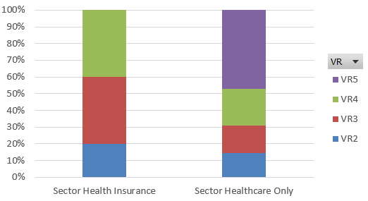

This result is highly aligned with our conclusion in previous analysis of the dilemma of the health insurance companies. Capital market shows less confidence in those health insurance companies compared to companies in Sector Healthcare Only.